Integrating libQRCoder to a Xcode Project

REVISION HISTORY

|  |  |  |  |
| --- | --- | --- | --- |
| **DATE** | **VERSION** | **AUTHOR** | **UPDATE DESCRIPTION** |
| Aug 26, 2020 | 1.0 | Gautham Velappan | Initial Draft |
|  |  |  |  |
|  |  |  |  |
|  |  |  |  |

## In this document, we will consider integrating a static library to an existing project.

## The document is mostly like a step-by-step how-to tutorial and does not cover a lot of theoretical and historical topics.

1. The first thing is that we need to add the static library files to the new/existing project. To reach that, right-click on the project name in the project navigator and select Show in Finder.
2. Copy the provided lib archive(lib.zip) file and paste it in the project directory.
3. Now unarchive the lib.zip to see the lib folder in the current location. Now you can discard the lib.zip after the extraction is successful.

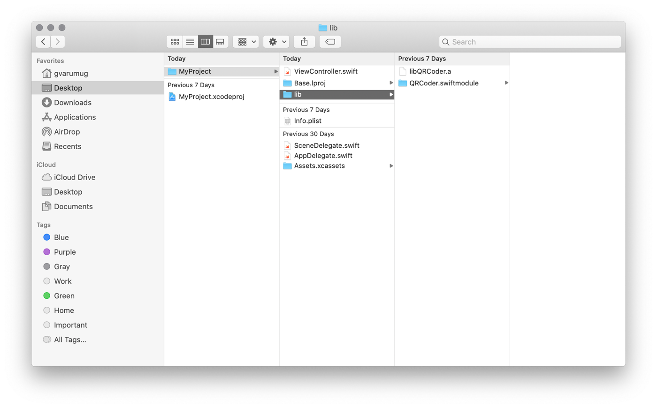

1. Select the project’s name in project navigator, then select General, and select your’s application target. The section Linked Frameworks and Libraries has to contain a line with libQRCoder.a. If it does not, press the + button and select it manually. Make sure that the Required status is selected.

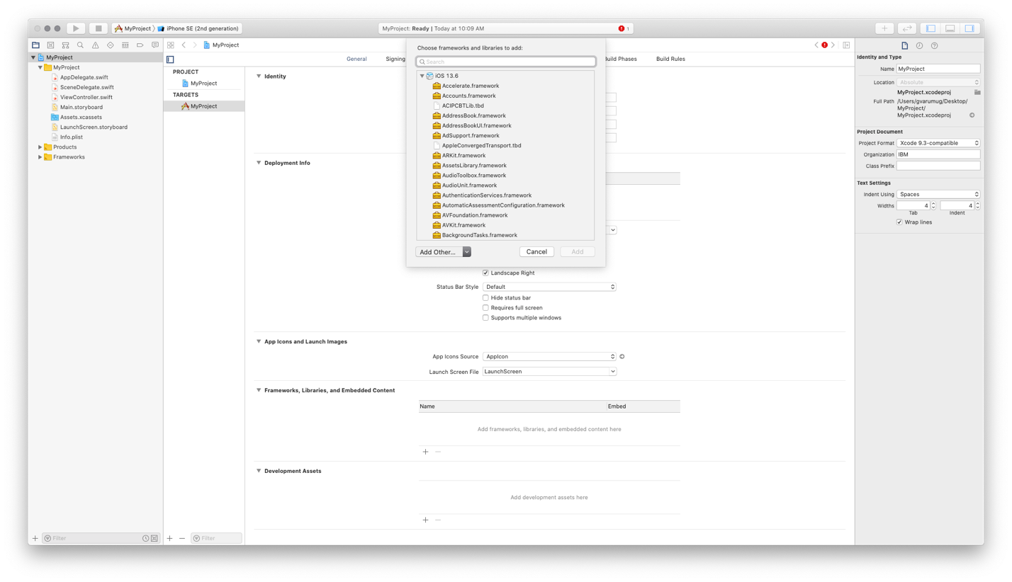

1. After that, go to the Build Phases tab, expand Link Binary with Libraries, and make sure that it contains a line with libQRCoder.a. If it does not, again, add it manually and set it to required.

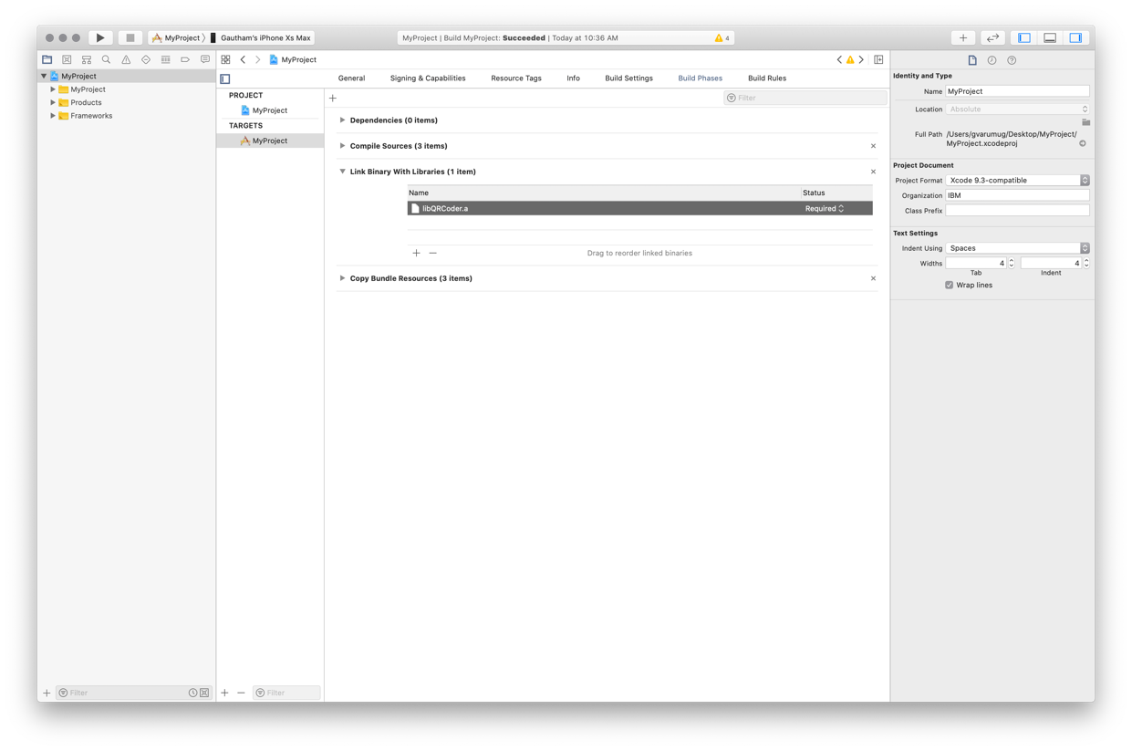

1. Finally, we’ve reached the last, and maybe the most sensitive integration step — setting paths. It’s a step where it’s very easy to make a mistake, so be neat and careful.

In the Build Settings tab, select your target, select All, and Combined.

In the search field in the top-right corner, type Search Paths. Copy the path from Library Search Path and paste it to Import Paths.

If there is no value in Library Search Path, add a new one, $(PROJECT_DIR)/lib. Do the same for Import Paths.

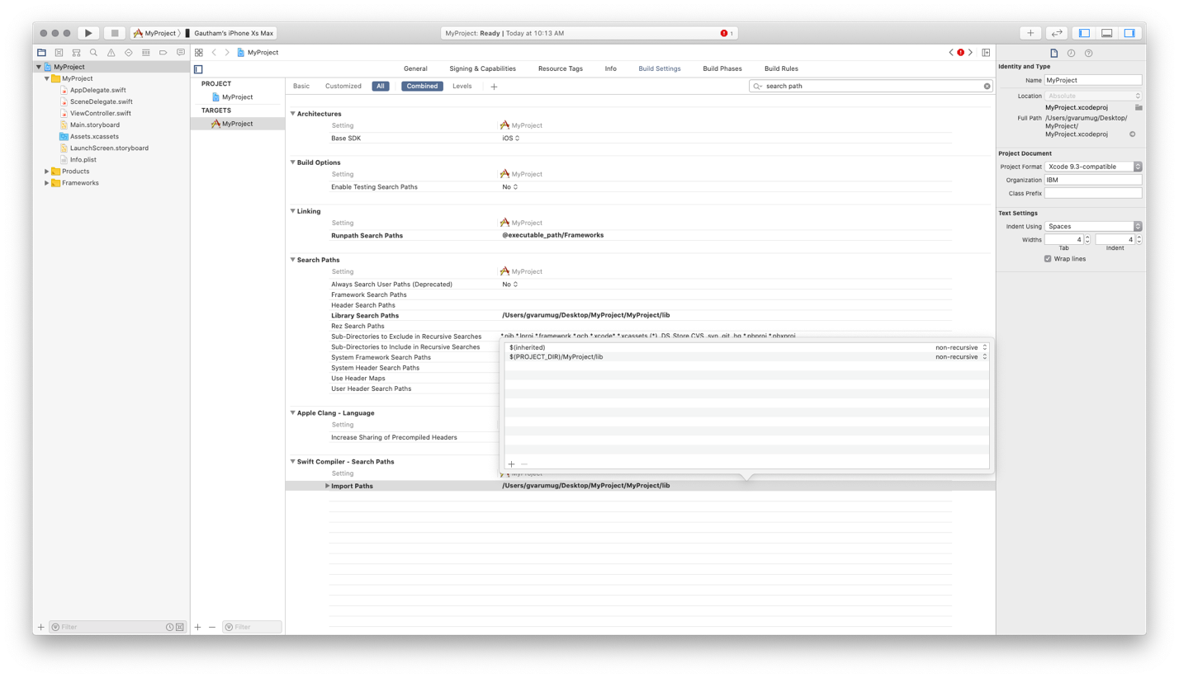

1. Then, go to your ViewController class and use the library capabilities

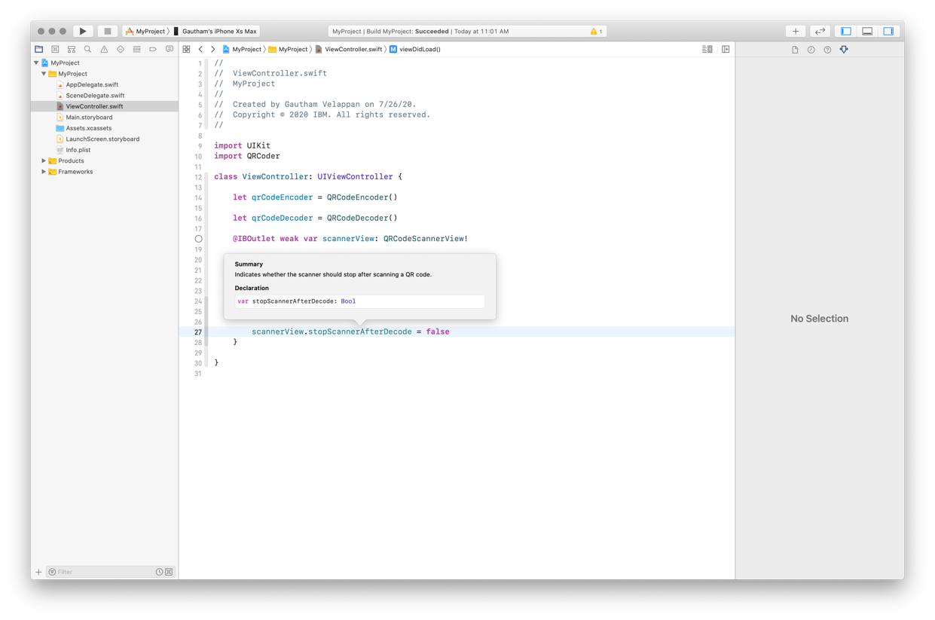

Import the QRCoder library. It will give you the ability to use the code from the static library

Create an instance of QRCoderEncoder, or QRCodeDecoder class that belongs to the library

These instances will give the ability to use the library methods.

More details about the library can be found in the library documentation or at libQRCoder inline documentation.